Year 3 | Lesson 1 | Lesson 2 | Lesson 3 | Lesson 4 | Lesson 5 | Lesson 6 | Lesson 7 | Lesson 8 | Lesson 9
Date | 9th-13th Sep | 7th-11th Oct | 11th-15th Nov | 9th-13th Dec | 27th-31st Jan | 3rd-7th March | 31st March- 1st April | 12th-16th May | 16th-20th June
Year 3  Topic | Near and far | Near and far | Shades of colour | Shades of colour | Polar opposites | Prehistoric Britain | Prehistoric Britain | Dive in! | Ancient Egypt
Curriculum Link | Art & Design  Geography-Short drawing | Working Scientifically  Geography | Working Scientifically | History/  DT | Maths/History  (RSPB-Big Garden bird watch) | Launch  Fire Safety | History: -Changes | Science | Science
Forest school focus | Who’s been framed?  Begin to indicate facial expressions in drawings/ Transient art | Grouping and classifying various materials: -  Plan  Do  Record  Report  Review  Use school map to local materials in different areas | Knowing our trees -Origins of trees, age and identification | Build a woodland hideout using a lean-to structure  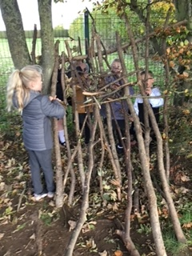 | Observe and Identify birds in their natural environment and record findings | Understand different methods to make a fire  Demonstrate safe use of a Kelly kettle  Name the components needed to make a fire | Stone age weapons  Knots-look at square lashings | Identify and describe the functions of different parts of flowering plants: roots, stem/trunk, leaves and flowers. | Plants with fragrant or aromatic properties  Identify a variety of herbs, discuss what are herbs and their uses?

